**Experiment no-04**

**//Multidimensional array:**

using System;

using System.Collections.Generic;

using System.Linq;

using System.Text;

namespace ConsoleApplication43

{

class employee

{

int n;

const int numStud = 3;

int cn = 1;

const int infoPerstud = 3;

string[,] studentInfo = new string[numStud, infoPerstud];

public void getData()

{

for (int i = 0; i < numStud; i++)

{

Console.WriteLine("Enter information for student no.:"+cn);

Console.WriteLine("Enter name : ");

studentInfo[i, 0] = Console.ReadLine();

Console.WriteLine("Enter roll no : ");

studentInfo[i, 1] = Console.ReadLine();

Console.WriteLine("Enter Dept : ");

studentInfo[i, 2] = Console.ReadLine();

cn++;

}

}

public void dispData()

{

Console.WriteLine("\n Student's information:");

for (int i = 0; i < numStud; i++)

{

Console.WriteLine("Enter information for student no.:" + cn);

Console.WriteLine("Name : " + studentInfo[i, 0]);

Console.WriteLine("Roll Number : " + studentInfo[i, 1]);

Console.WriteLine("Department: " + studentInfo[i, 2]);

Console.WriteLine("****************");

cn++;

}

}

}

class Program

{

static void Main(string[] args)

{

employee e = new employee();

e.getData();

e.dispData();

Console.Read();

}

}}

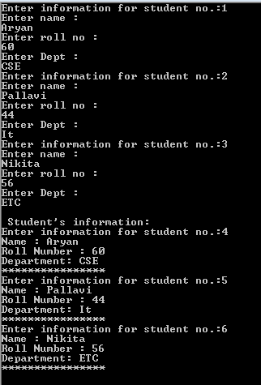



**Jaggged Array:**

using System;

using System.Collections.Generic;

using System.Linq;

using System.Text;

namespace JaggedArray

{

class Program

{

static void Main(string[] args)

{

// declare a jagged array

int[][] jaggedArray = new int[2][];

// set size of Jagged Array Elements

jaggedArray[0] = new int[3];

jaggedArray[1] = new int[3];

// initialize the first array

jaggedArray[0][0] = 87;

jaggedArray[0][1] = 39;

jaggedArray[0][2] = 56;

// initialize the second array

jaggedArray[1][0] = 94;

jaggedArray[1][1] = 67;

jaggedArray[1][2] = 85;

// outer for loop

for (int i = 0; i < jaggedArray.Length; i++)

{

Console.Write("Marks of student :" );

// inner for loop

for (int j = 0; j < jaggedArray[i].Length; j++)

{

Console.Write(jaggedArray[i][j] + " ");

}

Console.WriteLine();

}

Console.ReadLine();

}

}

}

